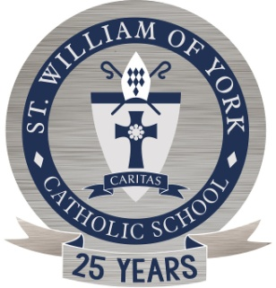
ST. WILLIAM OF YORK
Catholic School

DIOCESAN SCIENCE FAIR /CATEGORY DESCRIPTIONS

1. Behavioral and Social Science – Human behavior, social and community relationships.

2. Biochemistry – Chemistry of life processes-molecular biology, molecular genetics, photosynthesis, food chemistry, hormones, enzymes, etc.

3. Botany – Study of plant life-agriculture, horticulture, forestry, plant taxonomy, plant psychology, plant genetics, hydroponics, algae, etc. Please monitor projects to respect all life (plants and animals).

4. Chemistry – Study of nature and composition of matter and laws governing it.

5. Computer Science – Study and development of computer software and hardware and associated logical devices.

6. Earth and Space Sciences – Geology, mineralogy, physiography, oceanography, meteorology, climatology, astronomy, speleology, seismology, geography, etc.

7. Engineering – Technology: projects that directly apply scientific principles to manufacturing and practical uses.

8. Environmental Sciences – Study of pollution (air, water, and land) sources and their control; ecology.

9. Mathematics – Development of formal logic systems or various numerical and algebraic computations, and the applications of these principles- calculus, geometry, abstract algebra, number theory, statistics, complex analysis, probability.

10. Medicine and Health – Study of diseases and health of humans.

11. Microbiology – Biology of microorganisms.

- Physics – Theories, principles, and laws governing energy, motion, forces, and their effects on matter.

- Zoology – Study of animals, including diseases, behavior, and health.

Please monitor projects to respect all life (plants and animals).

