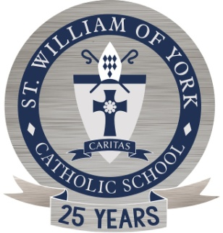
ST. WILLIAM OF YORK
Catholic School

November 2, 2017

Dear Middle School Students and Parents,

Greetings from the Science Classroom at St. William of York! It is at this time of the year, that the students will begin to prepare for the annual Science Fair. All Middle School Students will participate in the St. William of York Science Fair on February 15, 2018.
The students will begin to brainstorm, research, and select a category in which they are interested to pursue their projects. We will use some class time to do research and work on the project. The students will also write a research paper about their topic. During the school Science Fair, students will present their projects on tri-fold poster boards to the judges, who will use the attached Judging Sheet. Each student will compile their papers, including a research paper, in a 3-ring binder.
A select number of 7th and 8th grade students will be chosen to represent St. William of York and participate in the Diocesan Science Fair on April 14th, 2018 at Paul VI Catholic High School. Lastly, we are in need of parents who are interested in judging and assisting at the St. William of York Science Fair; please consider!
Please let me know if you have any questions.

Sincerely,
Miss Dixon
mdixon@stwillschool.org

Student Name:___________________________________________

Parent’s Name & Signature:_______________________________________________

Are you interested in judging at our Science Fair at St. William of York on
February 15(9am-12pm)?

Yes / No

